Lab 02 : Arithmetic Operations, Discrete-time and Continuous-time Signals and Processing

Syed M. Asad Ali sa09475
January 17th, 2025

Lab Report

Name: Syed M. Asad Ali | Student ID: sa09475

Task 1:

Code(1):
x = 15.5 + 3.175i;
%(a)
real(x)
%(b)
imag(x)
%(c)
conj(x)
%(d)
angle(x)
%(e)
abs(x)

Results:

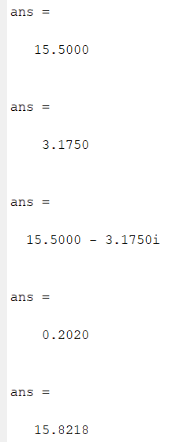

Comments:

Code(2):

ang = deg2rad(45) %convert degrees to radians
y = 5
[a, b] = pol2cart(ang, y) %gives values of real and imaginery part
cart= a +b*i %gives cartesian form
%(a)
real(cart)
%(b)
imag(cart)
%(c)
conj(cart)
%(d)
angle(cart)
%(e)
abs(cart)

Results:

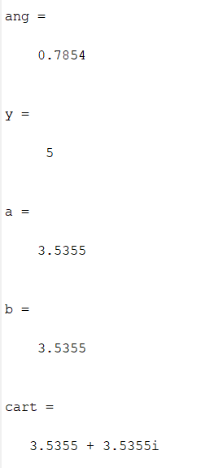 -- 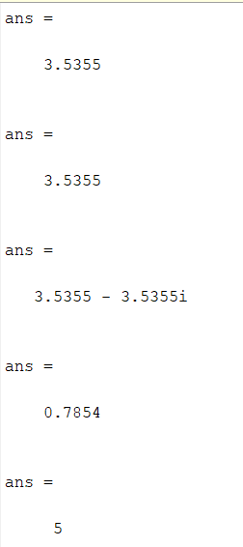

Comments:

Try 1:

Code:
n = 0:10; % Discrete-time n is defined which goes from 0 to 10 in unity sampling interval.
y = cos(n); % A sinusoidal function y[n] is defined attaining values −𝟏 ≤ 𝒚[𝒏] ≤ 𝟏.
figure; plot(n, y, ':o'); % A continuous-time graphical plot of the signal y[n] where circular markers are used to represent values connected with a dotted line.
figure; stem(n, y); % A more appropriate discrete-time graphical representation

Results:

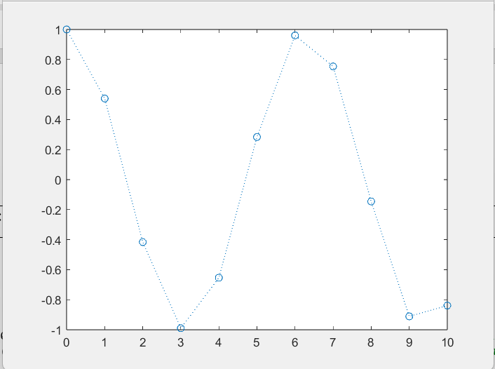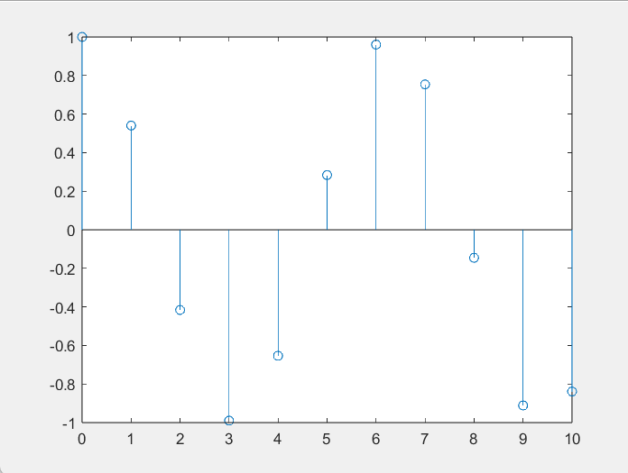

Comments:

Try 2:

Code:
Ts = 0.1; % Defining sampling time, the time interval between two consecutive samples
Fs = 1/Ts; % Defining sampling frequency, the number of samples per second
t = 0:Ts:10; % Defining time span
y = cos(t); % Obtaining a discrete-time signal
figure; % Using subplots to depict two plots in one figure
subplot 121; plot(t, y, ':o');
subplot 122; stem(t, y);

Results:

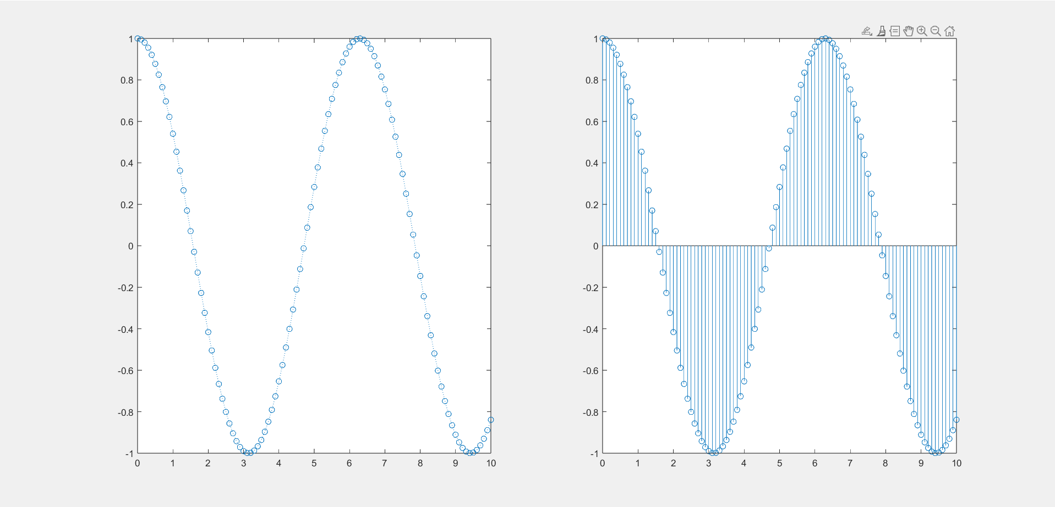

Comments:

Task 2(a):

Code:
n = 0:10;
y = cos(n);
figure; plot(n, y, ':o');
title('Try1- CT Graph of cos(n) with unity Interval')
xlabel('n')
ylabel('cosn')

figure; stem(n, y);
title('Try1 - DT Graph of cos(n) with Unity Interval')
xlabel('n')
ylabel('cos(n)')

Ts = 0.1;
Fs = 1/Ts;
t = 0:Ts:10;
y = cos(t);
figure;
subplot 121;
plot(t, y, ':o');
title('Try2 - CT Graph, 0.1 interval')
xlabel('t')
ylabel('cos(t)')

subplot 122;
stem(t, y);
title('Try2 - DT Graph, 0.1 interval')
xlabel('t')
ylabel('cos(t)')

Results:

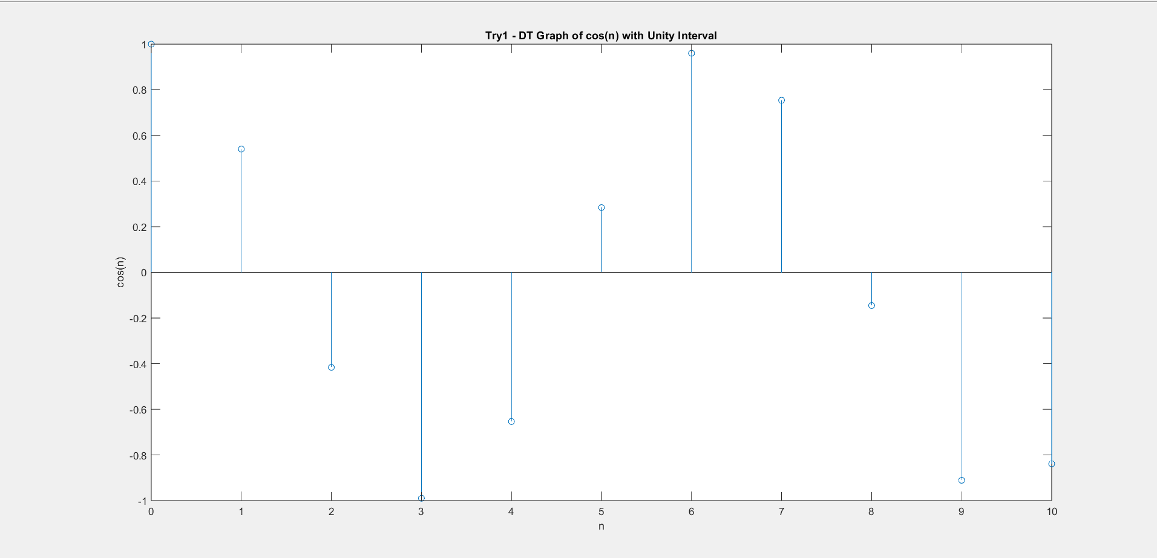

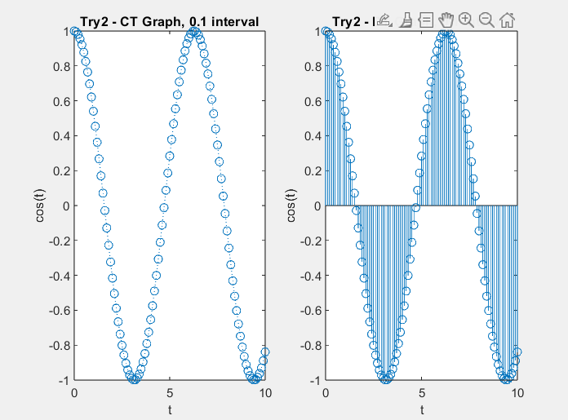

Comments:

Task 2(b):

Code:
Fs = 50; %50Hz
Ts = 1/Fs;

t = 0:Ts:3;
x = 3*exp(-t).*cos(20*t + pi/3);
figure;
stem(t,x)
title('DT Graph of x(t) with x-axis Ts')
xlabel('t')
ylabel('x(t)')

Results:

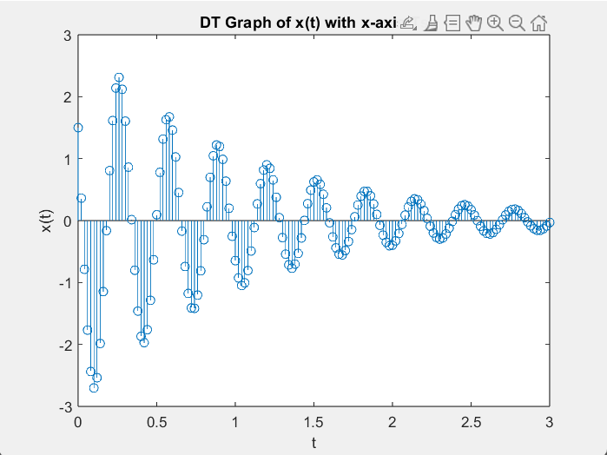

Comments:

Try 3:

Code:
clc;
clear
t = -20:1:20;
y = mod(t,5);
z = (t>=0);
subplot(1,2,1);
stairs(t,z,'linewidth',2)
title('Unit-step signal');
xlabel('Time');
ylabel('Amplitude');
axis([-20 20 0 1.1]);
subplot(1,2,2);
plot(t,y,'linewidth',1.5)
title('Sawtooth signal');
xlabel('Time');
ylabel('Amplitude');
axis([-20 20 0 5.2])

Results:

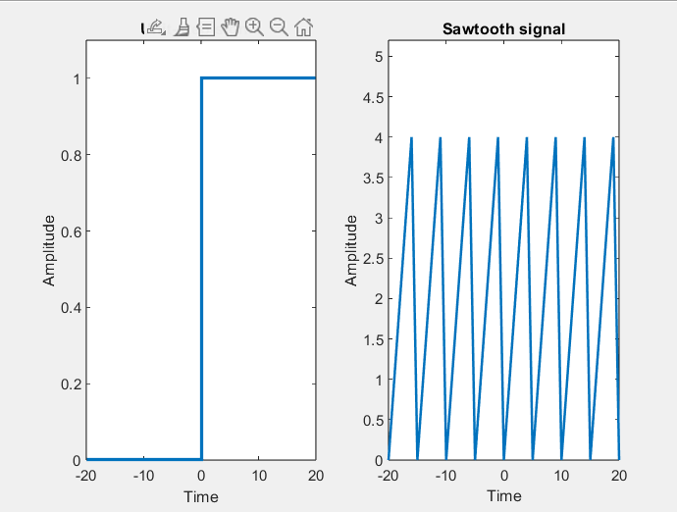

Comments:

Task 3:

Code:
clc;
clear
t = -20:0.1:20;
y = mod(t,5);
z = (t>=0);
figure;
plot(t,z)
xlim([-20 20])
ylim([-1 1])
hold on
title('Joint Unitstep-Sawtooth signal');
xlabel('Time');
ylabel('Amplitude');
x=sawtooth(t,0.2)

plot(t,x)
xlim([-20 20])
7
ylim([-1 1])
legend("unit-step","sawtooth")

Results:

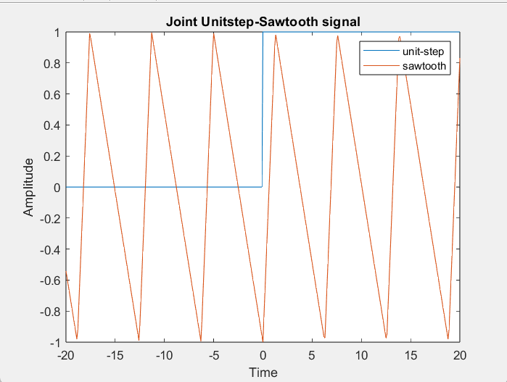

Comments:

Task 4:

Code:

Results:

Comments:

Lab Evaluation Assessment Rubric

# | Assessment Elements | Level 1: Unsatisfactory  Points 0-1 | Level 2: Developing  Points 2 | Level 3:Good Points 3 | Level 4:Exemplary Points 4
LR2 | Program/Code/ Simulation Model/ Network Model | Program/code/simulation model/network model does not implement the required functionality and has several errors. The student is not able to utilize even the basic tools of the software. | Program/code/simulation model/network model has some errors and does not produce completely accurate results. Student has limited command on the basic tools of the software. | Program/code/simulation model/network model gives correct output but not efficiently implemented or implemented by computationally complex routine. | Program/code/simulation  /network model is efficiently implemented and gives correct output. Student has full command on the basic tools of the software.
LR5 | Results & Plots | Figures/ graphs / tables are not developed or are poorly constructed with erroneous results. Titles, captions, units are not mentioned. Data is presented in an obscure manner. | Figures, graphs and tables are drawn but contain errors.  Titles, captions, units are not accurate. Data presentation is not too clear. | All figures, graphs, tables are correctly drawn but contain minor errors or some of the details are missing. | Figures / graphs / tables are correctly drawn and appropriate titles/captions and proper units are mentioned. Data presentation is systematic.
LR9 | Report | All the in-lab tasks are not included in report and / or the report is submitted too late. | Most of the tasks are included in report but are not well explained. All the necessary figures / plots are not included. Report is submitted after due date. | Good summary of most the in-lab tasks is included in report. The work is supported by figures and plots with explanations. The report is submitted timely. | Detailed summary of the in- lab tasks is provided. All tasks are included and explained well. Data is presented clearly including all the necessary figures, plots and tables.
LR10 | Analysis | Results are not interpreted or are analyzed incorrectly. | Analysis of the obtained results is incomplete. Conclusions are not drawn. | Results are analyzed and concluded but are not well explained and justification is not provided with the help of reasoning. | Results are well analyzed supported with reasons. Good comparison is made between the theoretical and experimental results with correct and useful conclusion.
AR4 | *Report Submission | Not accepted after 1 week. | Late submission after 2 days and within 1 week. | Late submission after the lab timing and within 2 days of the due date. | Timely submission of the report and in the lab time.
AR7 | Report Content/Code comments | Most of the questions are not answered / figures are not labelled/ titles are not mentioned / units are not mentioned. No comments are present in the code. | Some of the questions are answered, figures are labelled, titles are mentioned and units are mentioned. Few comments are stated in the code. | Majority of the questions are answered, figures are labelled, titles are mentioned and units are mentioned. Comments are stated in the code. | All the questions are answered, figures are labelled, titles are mentioned and units are properly mentioned. Proper comments are stated in the code.

